Data procedures for Student+Info.xlsx:

1. Data was collected and given by UpGrad (E-learning platform) while undertaking module 7 of ‘Business Analytics’ course.
2. Spreadsheet name “Module 7.2 Student+Info.xlsx”
3. Received on 27th Aug,2020.

Cleaning:

1. Removed duplicate student ID
2. 56 blanks found out of which 4 rows had blanks >= 4.

=IF(COUNTBLANK(C2:F2)>=4,1,0)

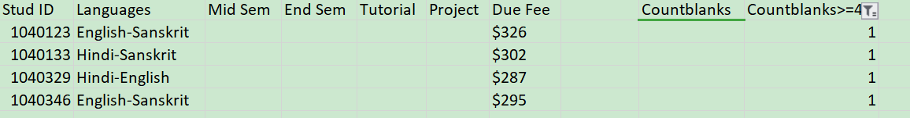

1. New columns added. “FirstLanguage” and “SecondLanguage” (after the countblank>=4 calculation)



Calculations:

1. Average MidSem marks = 82.27
2. Sum of due fees = 10,38,025
3. No. Of students opted for Sanskrit as secondary language = 239